

# First author

Oliver Hliddal, oliver.hliddal@uzh.ch, 18-737-528

**Second author**

Jan Weber, jan.weber@uzh.ch, 16-718-256

**Third author**

Stéphanie Wismer, stephanie.wismer@uzh.ch, 16-731-76

**Fourth author**

Shijie Jiang, shijie.jiang@uzh.ch, 16-611-345

**Fifth author**

Nino Scherrer, nino.scherrer@uzh.ch, 12-729-216

**Sixth author**

Clive Charles Javara, clivecharles.javara@uzh.ch,18-746-792

**Seventh author**

Chen-Yen Kao, chen-yen.kao@uzh.ch, 18-715-680

# Abstract

In this paper we introduce the idea of an application which helps the user to order food in advance before arriving at the restaurant in order to avoid the waiting time.

In the first section of this paper we present the overall concept of the application along with the necessary background research. It was conducted in the form of interviews with people, who generally visit restaurants.

In second section, we discuss about the possible stakeholders, who would most likely benefit from our application or are affected by it, either directly or indirectly. Furthermore, this report also argues about the eventual problems, which may occur during the usage of the application. But at the same time, this paper also deals with the present problems we face in the process of ordering food from a restaurant and explains how our application is going to address such issues.

It is also hoped to conduct further interviews to gather more information of how the application should look like and what functionalities are needed to make user actually want to use this application

**Introduction**

Many of us know the situation, in which we only have a short lunch break and have to eat outside. The decision where to grab food is mostly dependent on the amount of time that we have. In a restaurant you first have to get a table, then look at the menu, choose the food that you want to eat and then you have to wait until it arrives. This is mostly time consuming, and when the food finally arrives you have to eat in a hurry because you do not want to be late for work. In our project for the course “Human Computer Interaction” we like to address exactly this problem. We like to implement an app called “Come eat!” that allows you to order the food beforehand. On this application the user can book a table as well as order the food he wants to eat. So when he/she arrives at the restaurant the food is already prepared, so the user has enough time to consume the meal. In the following article we will quickly present our idea and afterwards, we are going to talk about the Background Research we have done. In this part we will talk more precisely about the interview outcome, possible problems that come along with the application but also talk about the stakeholders. At the end we will shortly talk about our further steps.

**Presenting our Idea**

We would like to implement an application that makes it possible to reserve a table at a restaurant and at the same time makes it possible to choose the food you like to eat there. In Switzerland there already are apps quite similar to our idea. One of them is called eat.ch and makes it possible to deliver food at home without having to make a call (Eat.ch). We took this app as example because there are many functions that we are also planning to have in our own app. There exist a lot of Apps to order food which you can pick up at a restaurant, but we haven’t found any well-established app where you can order your food previously and eat it at the restaurant.

**Background Research**

**Interview Outcome**

We have done three interviews to figure out what people think about such an app and how they would use it. At the beginning we asked general questions about their restaurant experiences to find out what is of primary importance in a restaurant for the visitors. After analysing our interviews we can say that the quality of the food, the waiting time, the service and the ambience are the most important factors which decides, if a restaurant will be visited a second time.

From the information extracted from our interviews we can assert that people often decide spontaneously, to visit a restaurant and that they prefer restaurants they already know in such situations. Additionally such a behaviour is also supported by the cognitive psychological approach which shows that familiarity is a part of cognition that will influence users on their choices (Longart, Pedro (2015)). 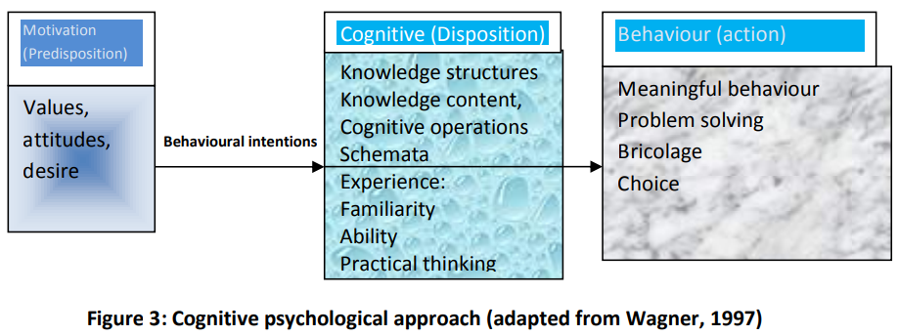

*Figure 1: Cognitive psychological approach (adapted from Wagner, 1997). (Longart, Pedro (2015))*

To support this behaviour with our app we want to integrate restaurant suggestions about restaurants in the near surrounding, but also a list where the user can put his favorite restaurants so he doesn't lose any time by searching the restaurant.

It was also mentioned during the interviews, that people sometimes feel stressed when they have to order food at the restaurant because they have not enough time to make a decision. This problem would be solved with our app, because the user can take as much time as he wants to choose the meal, that he wants to eat.

At the end of the interview we asked some questions concerning our idea with the app. We asked them what they would like us to include in the app. They mentioned, that it would be helpful, if there would be suggestions about restaurants in near surrounding. What should also be included is a rating tool, arrival possibilities, infos about the meal and what is contained in it (gluten-free, vegan), payment possibilities (maybe also a possibility to pay directly on the app) and food suggestions for the different restaurants. It was also mentioned that it would be fundamental to have a good tool to search for certain characteristics in a restaurant. This means that you can search for example for restaurants with gluten-free meals, or restaurants with chinese food.

**Stakeholders**

Stakeholders are anyone who is affected by the success or the failure of a system. The primary stakeholders are the end users of the system. This would be the people who will use the app “Come Eat!” to book a table and choose the food they want to eat through the app.

Secondary stakeholders are people who do not use the system directly, but who receive output from it and can provide input to it. These are the restaurant, the service staff as well as the cook. The restaurant has to upload the informations about the menu to the app, as well as the location of the restaurant and the tables. The service staff and the cook are also affected by the app, because they have to prepare the meal in advance, this can be as well positive because they can better organize their work and prepare things in advance. Also the app founders, who have to update the app information (how many places are still available in a restaurant) can be secondary stakeholders.

Tertiary stakeholders are those, whose profit increase or decrease as a result of the success of the system. This can be the restaurant owner, if he does not actively participate at the restaurant business, but gains more money if the app is successful. Also other restaurants can be tertiary stakeholders. If a restaurant is not participating the app, it can be an advantage or a disadvantage, depending on the success or respectively from the failure of the app. So it is important, that we take all stakeholders into account when designing the app. (Prof. Huang, Elaine (2017))

**Problems that the App addresses:**

The App addresses several problems. Firstly it enables people with a short lunch break to eat out in a restaurant because the time they have to wait on their meal is omitted. This also supports restaurants which do not support Fast Food, or Takeaway service. Secondly it enables the restaurant employees to better organise their time. There will be no problem to serve meals at the same time for a big group, because the cook can prepare the food in front. The App probably also generates new customers for the restaurants with good rating, and help the users to take a step out their comfort zone and try something new. The application brings also some advantages for people with allergies. If the restaurants note which meals are for example gluten-free, people who are affected with a gluten allergie can easily find restaurants where they can eat. This will probably also motivate such people to eat out more often, which also brings along another advantage for the restaurant.

**Problems that the can App cause:**

A big problem with the app is, if people do not show up at the restaurant or do not cancel their order or table. Then the restaurant will already have prepared the food and most likely has to throw it away. A solution to this problem would be, if the app would have an option which allows the user to cancel the reservation until 2 hours in advance. If the user does not cancel the meal at the right time and does not show up, he has to pay half of the price.

It could also be difficult if a big group want to go eat together and they have to choose their food on one phone. Therefore we think that it would be useful if there was a tool to invite friends to a booked table, so that they can look up the menu at their own phone.

**Further Steps:**

We had some difficulties getting enough usable information out of the interviews that we can use to build the app. Therefore we will do some shorter follow up interviews where we concentrate more on the interview question concerning the app. After the follow up interviews we can start building our prototype. There we want to direct our focus on the desires of the users, so the things people mentioned in the interview. We will also focus on common design principles like the fundamental principles of interaction (Norman, Don (2013)).

**References:**

Prof. Huang, Elaine (2017). People Oriented Computing: “Computer Supported Cooperative Work”, Lecture 6, University of Zurich

Eat.ch, “Order meals online from the no. 1 in Switzerland”. Eat.ch GmbH. 13.10.2018. <https://www.eat.ch/en>.

Norman, Don (2013). “The design of everyday things: Revised and expanded edition”. Page 10-32.

Longart, Pedro (2015). “Consumer Decision Making in Restaurant Selection”(p.15-16). Diss. Buckinghamshire New University.

**List of Figures:**

Figure 1: Longart, Pedro (2015). “Consumer Decision Making in Restaurant Selection” (p.16). Diss. Buckinghamshire New University.